**2 The Graphics Rendering Pipeline**

**2.1 Architecture**

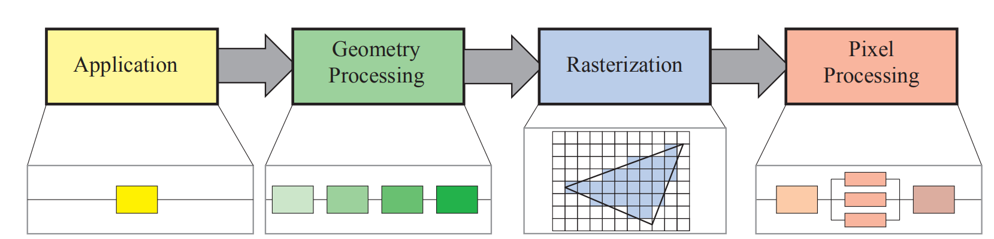

**2.2 The Application Stage**

**2.3 Geometry Processing**

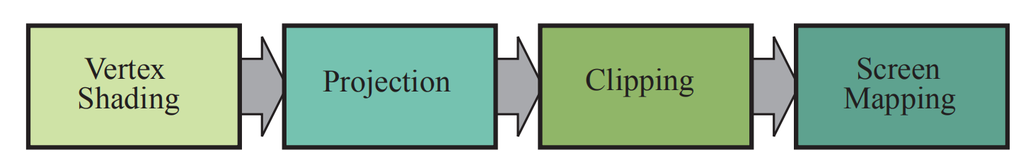

Vertex Shading：model space, world space, view space, clip space, normalized device coordinates, window coordinates.

Optional Vertex Processing: tessellation, geometry shading, and stream output.

**2.4 Rasterization**

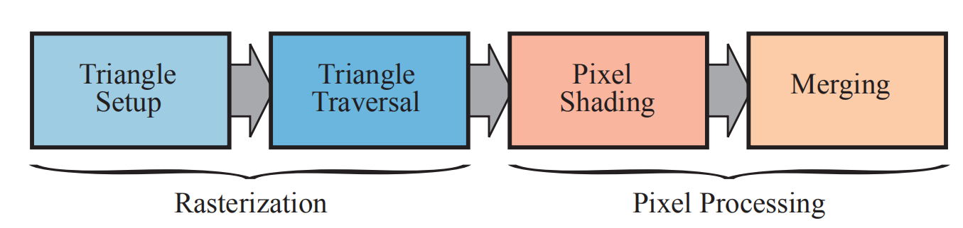

**2.5 Pixel Processing**

Merging: z-buffer, stencil buffer and blend.

**2.6 Through the Pipeline**